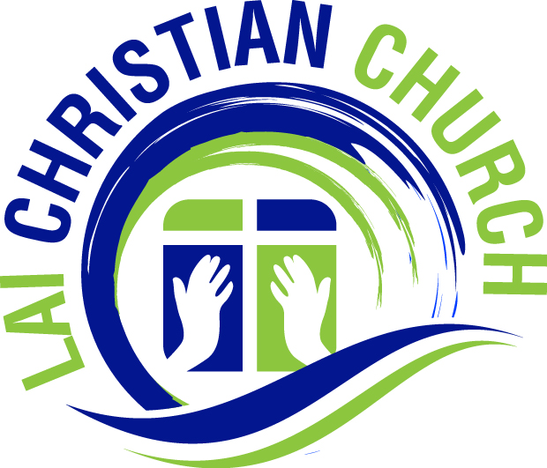
Lai Christian Church

- Church min: Lai Christian Church
- Address: 1710 35th Avenue, East Moline, IL 61244
- Curch Website: www.laichristianchurch.org, Email: lcc@laichristianchurch.com
- Thok Ni: Nov 29, 2012
- Members: 215
Tipil Ingcia | Tipil Inglo | Dihlak
116 | 99 | 215

- Church School ngakchia milu: Minung (60)
- 2021 Ngakchia Chuak Thar: Minung (1)
- 2021 Cheuhra cheukhat hmuhmi: $241,531.60
- 2022 Cheuhra cheukhat tinhmi: $250,000.00
- Missionary zohmi min: Rev. Kima Aung Than,
- College/University/Bible School Zohmi Zat: (Bible Minung-3. College Minug-2.)
- Pastors:
No | Min | Phone | Email ID
1 | Rev Thang Kio (Senior) | 309-2071905 | psthangkio@gmail.com
2 | Saya Dawt Lian Cung (Assit.) | 309-2810377 | dawtlcung@gmail.com

- Office Bearers
Ṭuanmi | Min | Phone | Email ID
Chaiman | Pu Ram Hei | 309-206-5092 | patlingpa@gmail.com
Secretary | Pu Bawi Bik | 309-716-8654 | bikbawi55@gmail.com
Treasurer | Pu Ngun Chum | 309-558-8466 | N/A
Nubu Chairman | Pi Zai Thluai | 309-350-3619 | zaithluai06@gmail.com
Mino Chairman | Pu Rual Hei | 309-235-7974 | rualhei665@gmail.com
Mission Dir. | Pu Hrin Ceu | 309-721-1196 | N/A
Church School Dir. | Sy. Dawt Lian Cung | 309-281-0377 | dawtlcung@gmail.com
Report Petu: Pu Bawi Bik

